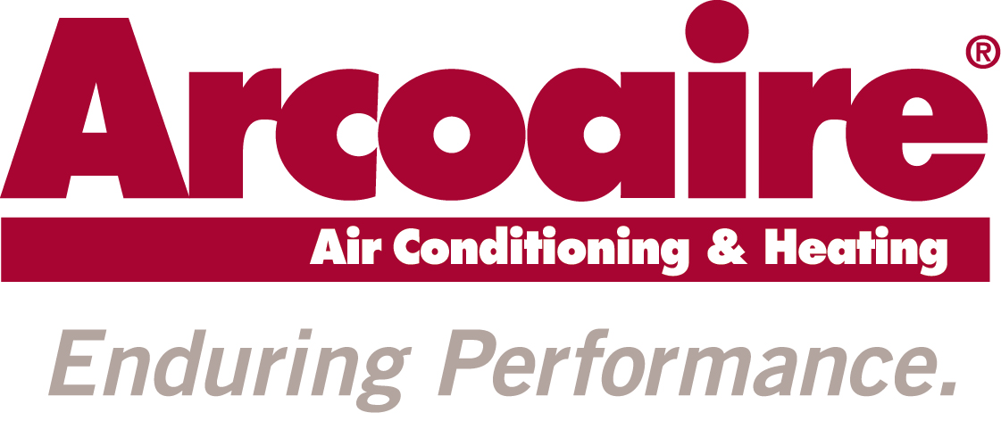
EBLAST
JOB NUMBER: 16-ICP-0038
DATE: 7/6/16

Arcoaire Product Excellence:

Version 1:

SUBJECT LINE: Stay comfortable all winter long

HEADLINE: Built Tough For Freezin’ Season

Arcoaire® heating systems are built rugged so you stay comfortable all winter long. They’re also designed with convenience in mind, when paired with the Observer® communicating control with Wi-Fi® capability that lets you remotely adjust your home comfort settings. Call [Dealer name] today to discover how Arcoaire heating systems deliver the rock-solid performance you deserve—even in the toughest winter weather.

Call (555) 123-4567 or find us online at ABCHVAC.com.

Wi-Fi® is a registered trademark of the Wi-Fi Alliance Corporation.

Version 2:

SUBJECT LINE: Are you ready for winter’s worst?

HEADLINE: Rugged & Reliable … All Winter Long

Arcoaire® heating systems are built tough so you stay comfortable all winter long. They’re also designed with convenience in mind, when paired with the Observer® communicating control with Wi-Fi® capability that lets you remotely adjust your home comfort settings. Call [Dealer name] today to discover how Arcoaire heating systems deliver the rock-solid performance you deserve—even in the toughest winter weather.

Call (555) 123-4567 or find us online at ABCHVAC.com.

Wi-Fi® is a registered trademark of the Wi-Fi Alliance Corporation.
Arcoaire Dealer Quality:

Version 1:

SUBJECT LINE: Let [insert dealer name] keep you cozy

HEADLINE: We’re Just As Rugged As Winter

As your Arcoaire® dealer, [Dealer name] is ready for any challenge winter throws our way. Whether you need a fall tune-up to get ready for freezin’ season or a mid-winter emergency repair, we go the extra mile to keep you comfortable. [Dealer name] is the name to remember for rugged heating products and the reliable service that keeps you toasty all winter long.

Call (555) 123-4567 or find us online at ABCHVAC.com.

Version 2:

SUBJECT LINE: Our team is tough on winter

HEADLINE: Our Team Is Tough On Winter

As your Arcoaire® dealer, [Dealer name] is ready for any challenge winter throws our way. Whether you need a fall tune-up to get ready for freezin’ season or a mid-winter emergency repair, we go the extra mile to keep you comfortable. [Dealer name] is the name to remember for rugged heating products and the reliable service that keeps you toasty all winter long.

Call (555) 123-4567 or find us online at ABCHVAC.com.
Arcoaire Service:

Version 1:

SUBJECT LINE: A fall tune-up gets your furnace ready for winter

HEADLINE: Are You Ready For A Rugged Winter?

Before winter gets brutal, you need to make sure your heating system is up to the challenge. [Dealer name], your trained Arcoaire® dealer, can perform a timely fall tune-up that might even help lower your winter heating bills. Call us today and we’ll make sure your system performs its best when winter gets tough.

Call (555) 123-4567 or find us online at ABCHVAC.com.

Version 2:

SUBJECT LINE: Get ready early to handle winter’s worst

HEADLINE: Get A Head Start On Old Man Winter

Before winter gets brutal, you need to make sure your heating system is up to the challenge. [Dealer name], your trained Arcoaire® dealer, can perform a timely fall tune-up that might even help lower your winter heating bills. Call us today and we’ll make sure your system performs its best when winter gets tough.

Call (555) 123-4567 or find us online at ABCHVAC.com.

